What are practical ways to build trusting relationships and partnerships with non-traditional stakeholders?

Identify & Represent Community Needs | Include Participant Input | Build Relationships Through Networking | Engage & Activate Stakeholders | Create a Road Map | Celebrate the People and the Work | Ensure Sustainability
Site visit at least once a year to county program partners  Reflect and understand needs of target audience | Participatory, Inclusive processes  Participatory norms - ground rules  Neutral & skilled facilitation | Schedule breaks on agenda for networking  Standing/regular meeting schedule  Include networking at every meeting  Increase communication between IWP leads via regular, less formal meetings. | Avoid tokenism by having more than 1 rep from non traditional group  Include decision makers  Be as inclusive as possible  Get the right people  Empower people by affirming their expertise  Get one outsider (odd ball!)  Preserve collective interest  Have the right people at the table  Relevant, diverse representation  Consistent members/ participants  Value attendees equally | Charter with Role & responsibilities  Clear Vision and goals  Cast the vision clearly to motivate people  Provide ongoing clarification on why we are here  Action items with defined roles  Define desired outcomes & timeline  Define a common goal  Provide a visual schematic to that participants can see how their organization fits into the collaborative | Celebrate group & individual successes  Invite media attention to help amplify messages & success  Have fun!!!  Promotion & recognition of successes | Adaptability to ensure sustainability  Hold regular check-ins to review progress & relevance to goals (short & long term)  Leveraging Resources (people, money, time)
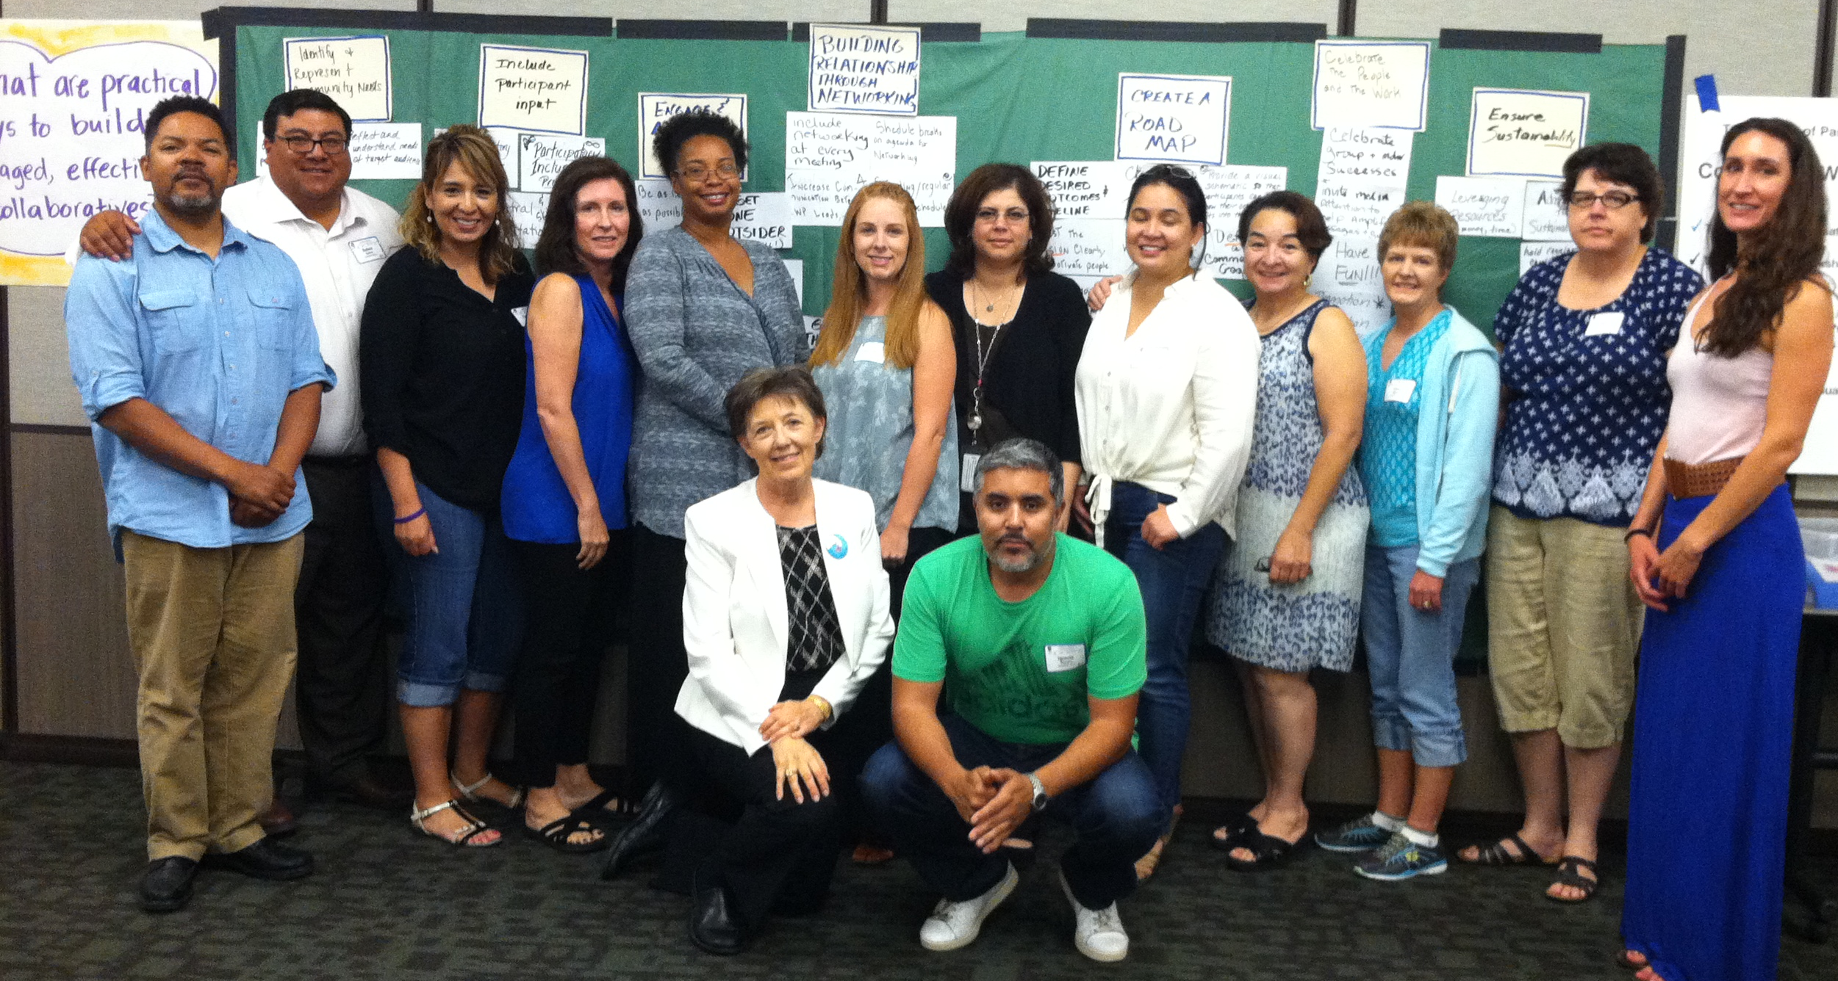
SNAP-Ed Consensus Workshop Results - Sacramento, June 24, 2016

